Mental Health Companion

*Analyzing and Visualizing Mental Health Through Online Presence*

*Target Audience*

The mobile application we are designing is targeted for individuals concerned about their own mental health or their children’s mental health.

*How it Works*

* The application will prompt users or parents to log in to their or their child’s social media accounts, which will (with their consent) scrape the text and/or images liked or posted by the account and send the raw text data to a server.
* If the source is an image we will use the Microsoft Computer vision API to draw what’s in the image into analyable text.

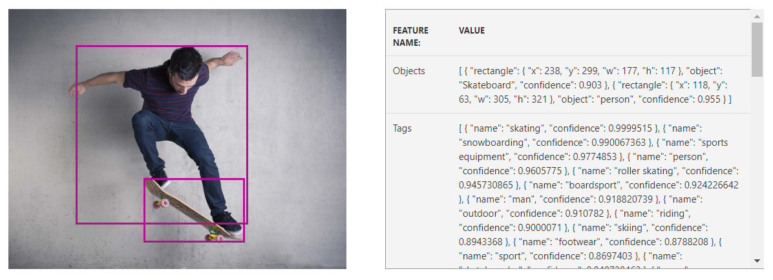

By pulling the objects with a high threshold confidence we can get a good idea as to what the user is looking at and is associating themselves with. Some objects and scenes like ‘amusement parks’ and ‘trees’ will show higher sentiment than ‘rain’ and ‘tombstone’

* Text data is then run through the [Bing Spell Check](https://azure.microsoft.com/en-us/services/cognitive-services/spell-check/) to insure the sentiment analysis understands everything well.

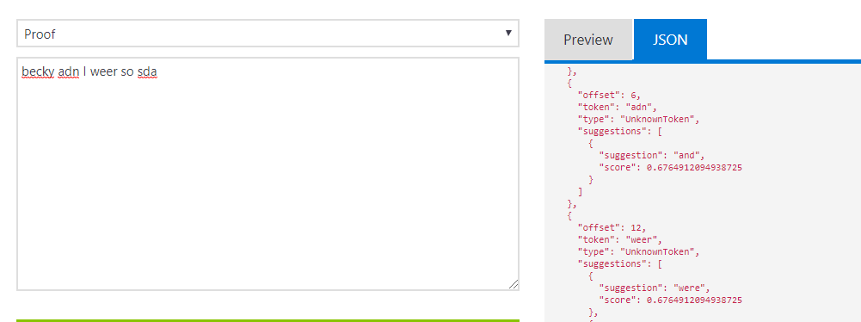

Unlike other spell checkers, the Bing spell checker by Microsoft converts all suggestions into JSON format as well, which can be used if we only want a certain confidence interval and want to ignore the suggestion it wants to make if it’s not high enough

* Text data is then uploaded and sent through the Microsoft Azure Sentiment Analysis API

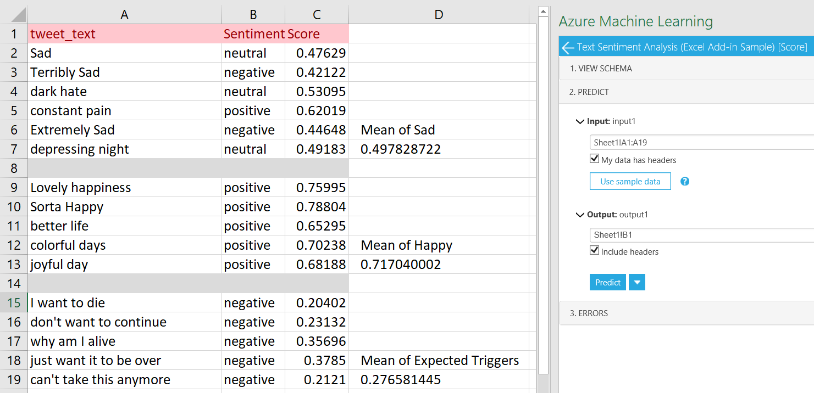

After doing some testing, we found it was really accurate when predicting tones and phrases we generally associate with depression and a concerning mental state

* After the data is analyzed and scored it is then sent back to the user where it can be visualized and report to the user of concerning drops or changes over time (for better or worse)

*Technologies*

* The coding languages/environments we plan to use are:
  + XCode because the application will be available for iOS users.
  + Android Studio because the application will be available for Android users as well.
  + With no experience in Android Studio or XCode, we are still planning to use these because mobile applications are extremely popular and mainstream, giving us the greatest access to data.
  + Python because Python is a great language to manipulate, sort, and analyze the data collected.
    - Based on moderate experience with Python, we’ll have a general idea of the best methods to collect and sort the data.
* Microsoft Azure Cognitive Sciences API because the ultimate sentiment score will be calculated from a machine learning process.
  + - For images, we would use the “Computer Vision” API by Microsoft to convert what’s in the image into captions which can be analyzed for sentiment as well
    - For captions or messages, we would use Microsoft’s “Bing Spell Check” and “Text Analytics” APIs to go from raw text to analyzable and visualizable data.
    - Based on previous experience dabbling in machine learning technology, we wanted to incorporate machine learning into this application and the microsoft API’s are the choice we’d make. Their programs are very generous in free monthly usage and have add-ons that can be used in programs like excel to make table and data management much easier and smoother

*Data Storage*

* Data does not need to be stored, but if social science researchers or psychological researchers are interested in utilizing the data we collect, then we could begin collecting data with proper consent.

*Accessing Data*

* Yes, access to data will likely come from the web/text scraping of voluntary participants’ social media accounts. The database accessed through APIs will take place through Microsoft Azure Machine Learning.